Angular Learn :

1. Angular Setup:

|  |  |  |  |  |  |
| --- | --- | --- | --- | --- | --- |
|  |  | |  | |  |
|  |  | |  | | |  |  | | --- | --- | | Angular Commands | description | | Dotnet run | Run dot net app | | Node js file |  | | Npm install | Npm install | | Node -v | Check node version | | Npm-v | Checj npm version | | ng version - for all check versions |  | | npm install -g @angular/cli |  | | ng serve --open |  | | Ng serve |  | | Ng build |  | | ng generate component component-name    ng g c component-name | Create new component | | ng g c PageNotFound --skip-tests | page not found | |
|  | * 1. Vscode download   2. You need node.js to install   3. Check node version , please close vscode whle installing and after that run as admin   4. Check npm version as well   5. Install angular cli from vs code ( npm install -g @angular/cli)   6. When create amd pushing new angular proj to git ignore this nodemuodules files   7. When cloning install npm for node modules  1. Angular Commands: | |  | |
| Angular Commands | description | |
| Dotnet run | Run dot net app | |
| Node js file |  | |
| Npm install | Npm install | |
| Node -v | Check node version | |
| Npm-v | Checj npm version | |
| ng version - for all check versions |  | |
| npm install -g @angular/cli |  | |
| ng serve --open |  | |
| Ng serve |  | |
| Ng build |  | |
| ng generate component component-name    ng g c component-name | Create new component | |
| ng g c PageNotFound --skip-tests | page not found | |
| ng new angular-tailwind | Install tailwind css | |
| Ng new angular17_without_standalone – standalone false | With out standalone below | |
| ng generate service services/Post | Create service | |

1. Important Points:
   * + App.component.html – is the first file for all navbar and routerlink

* <app-navbar></app-navbar>
* <router-outlet></router-outlet>
  + - Navbar .html
    - Next all pages – home , about, contact

1. **Few points:**

* Angualr 17 without standalone component means no app.module.ts. Below see standalone
* @Component({
* selector: 'app-root',
* standalone: true,
* imports: [NavbarComponent, RouterOutlet],
* templateUrl: './app.component.html',
* styleUrl: './app.component.css'
* })
* App.Route.ts has replaced App.Module.ts

**With out standalone :**

* Ng new angular17_without_standalone – standalone false : you will see app.module.ts

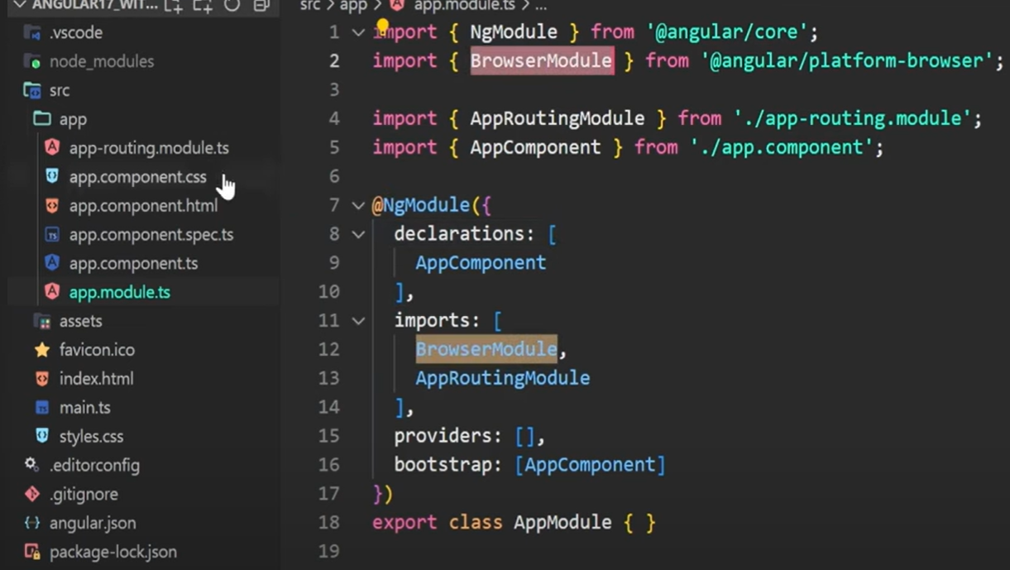

App.routimg.module.ts

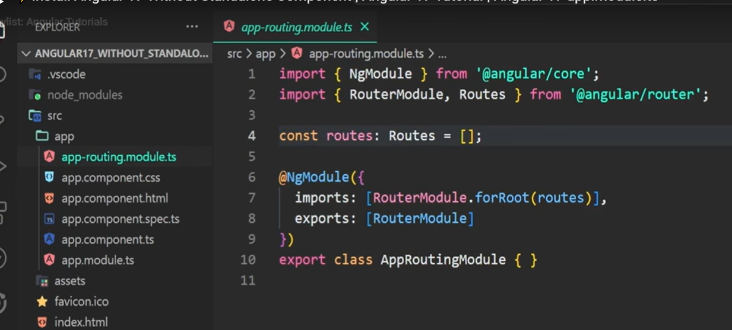

**App.component.ts**

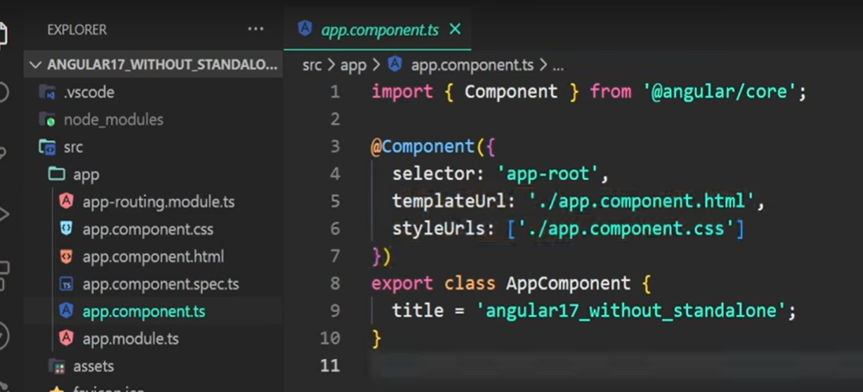

Resources:

1. Routing : phpnodetuts - main

<https://www.youtube.com/watch?v=lIb_gnleUns>

1. Questpond:

<https://www.youtube.com/watch?v=-9VcW7MBDs8>